# Ingesting data through FTP

(for Windows 10)

1. Go to Control Panel 🡪 Programs

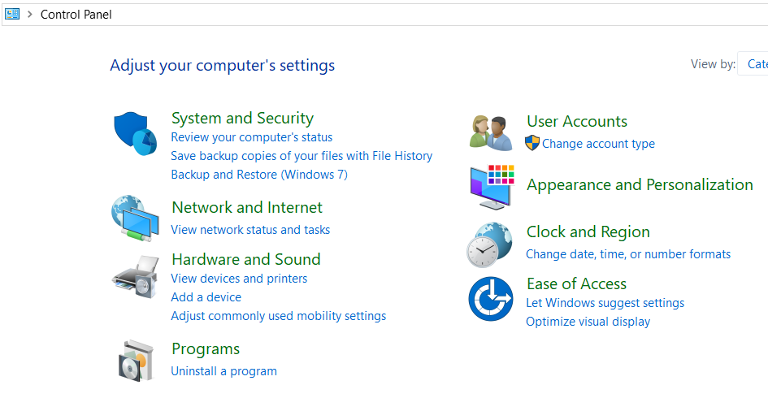

1. Click Program Features 🡪 “Turn Windows Features on or off”

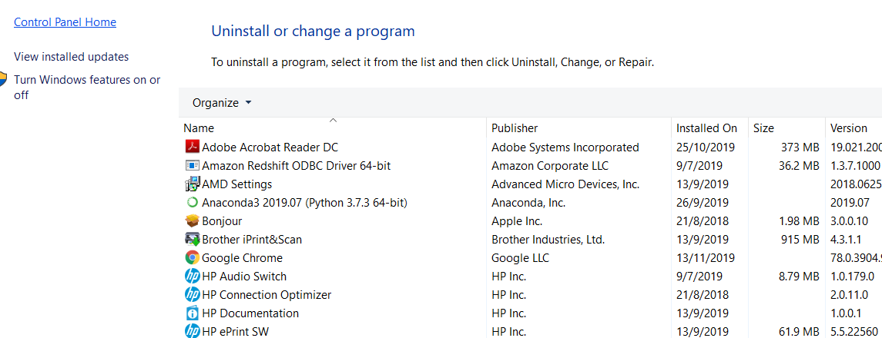

1. Check the following boxes:

* FTP Extensibility
* FTP Service
* ISS Management Console

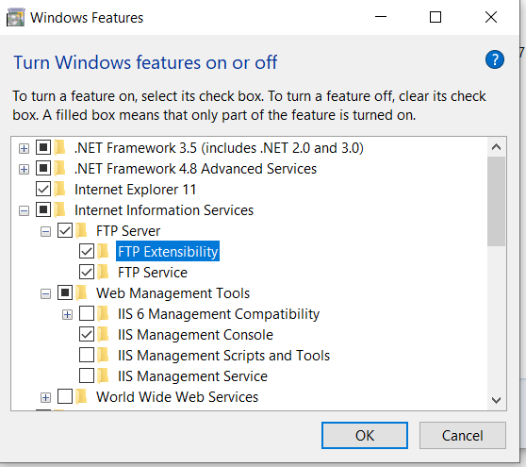

1. Click Ok and apply changes.
2. Go to Control Panel 🡪 **System and Security**

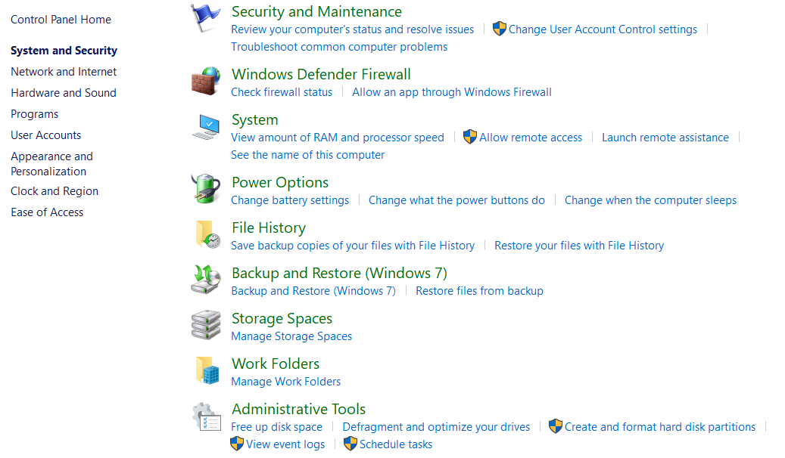

1. Go to Administrative Tools 🡪 Internet Information Services (IIS) Manager

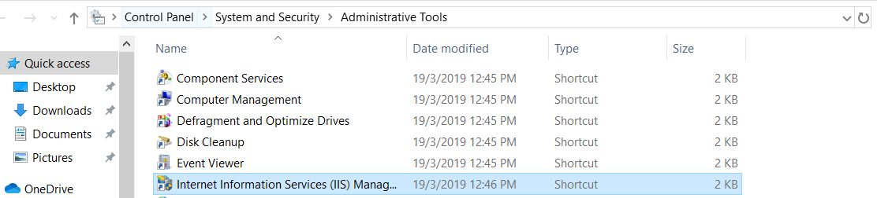

1. Right click on Sites, click on “**Add FTP Site**”

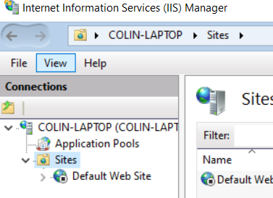

1. Input FTP site name. Configure Physical path to your local folder containing files to be ingested. Click Next.

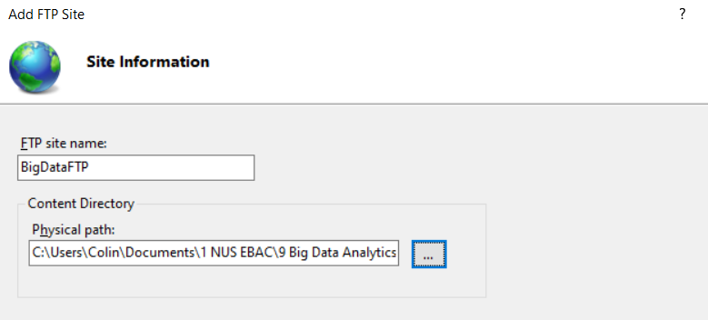

1. Use default binding settings. Under SSL section, select “**No SSL**”. Click Next

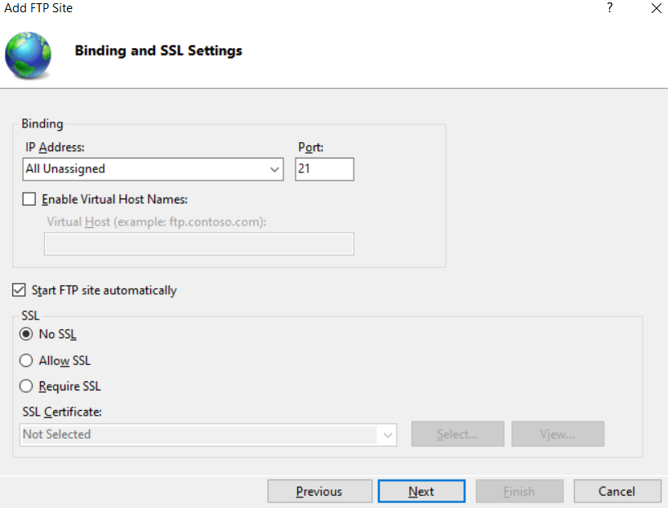

1. In the "Authentication" section, check the Basic option; select Specified users option; Type local account name to allow yourself access to the FTP server. Check the Read and Write options. Click Finish.

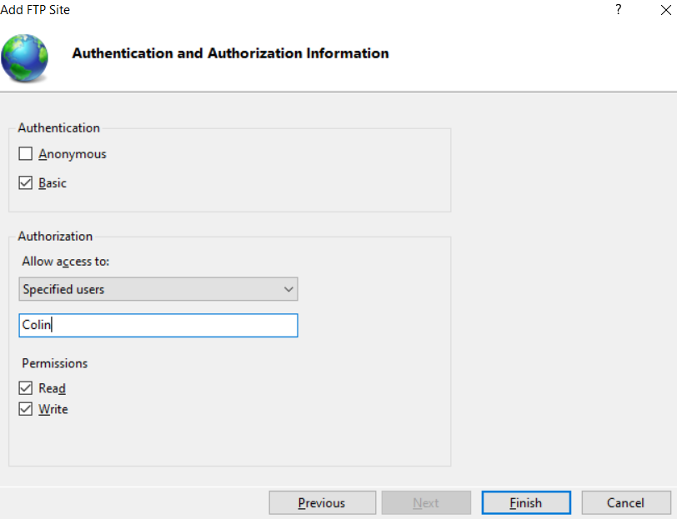

1. Go to Windows Defender Firewall. Click on “**Allow an app or feature through Windows Defender Firewall**”

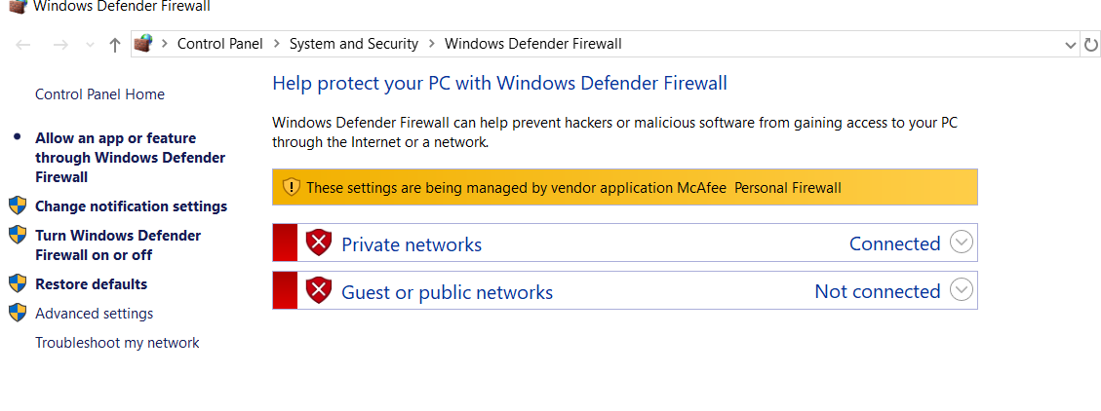

1. Click on Change Settings; check FTP Server, allow it on both public and private networks.